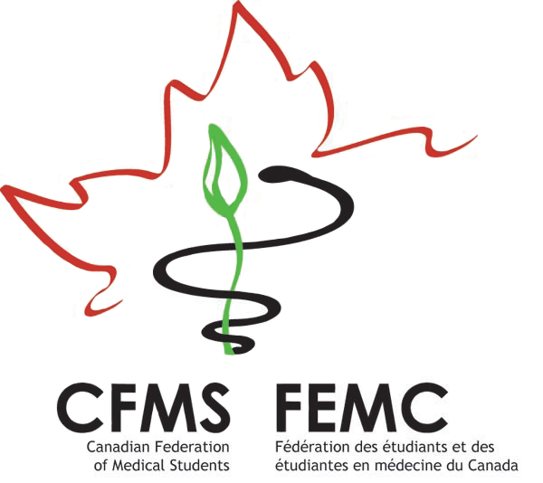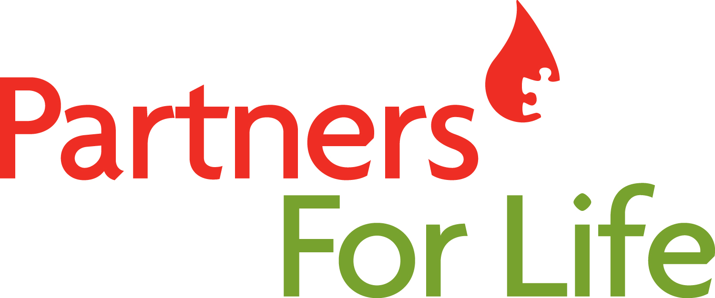



**The 3rd Annual Phlebotomy Bowl!**

**September 1 – February 29**

It’s time for the start of the 2015-2016 annual Phlebotomy Bowl!

Last year’s challenge was an amazing success – bringing in a total of 751 life-saving blood donations and a total of 105 new blood donors. Congrats to the top schools in 2014-15:

* Most Donations Per Capita: Dalhousie Medicine New Brunswick
* Most New Donors: University of British Columbia – Vancouver

This year’s challenge runs until February 29, 2016. Our goal is to contribute at least 800 donations, including at least 100 first-time blood donors. We’ll compete for two prizes again – one for the **most donations per capita**, and one for the **most first-time donors**. The winning schools will have their name engraved on their respective plaque which they can proudly display at their school for the year! This way, you get recognition and bragging rights for years!

**Here’s how you can help your school win:**

1. **Download the GiveBlood App or visit** [**blood.ca**](http://www.blood.ca)to find your nearest blood donor clinic and book your appointment to donate. Also watch for information about a donation campaign organized by your school’s Champions. Giving blood takes about an hour and you can donate every 56 days. Donate in September or October and you’ll have time to make three donations during the challenge!
2. **The only way your donation will count towards the bowl** is if you are registered under your school’s *Partners For Life* number. **Visit** [**www.blood.ca/joinpartnersforlife**](http://www.blood.ca/joinpartnersforlife) and register with your school’s Partner ID number listed below. This is a one-time registration. Once you register, your past and future donations will automatically count toward your school.

The Phlebotomy Bowl is all about inclusivity, therefore everyone can participate. If you’re not eligible to donate yourself, consider recruiting another donor, a friend, a collegue or a non-med student, to give blood on your behalf. Or help spearhead our partnership with Canadian Blood Services at your school. We’re still looking for more champions – especially first-year students to help out. Contact [salima.abdulla89@gmail.com](mailto:salima.abdulla89@gmail.com).

When you donate this September, you’ll also be helping to mark Childhood Cancer Awareness Month. Did you know that on average, it can take up to five blood donors to help one child undergoing cancer treatment and up to eight donors a week to help a child with leukemia? 1,500 children are diagnosed with cancer each year, and over 1,500 new blood donors are needed each week across Canada. Each new blood donor can change the life of a child who is fighting cancer.

Show your support for families affected by childhood cancer, save a life and help your school win the Phlebotomy Bowl by giving blood this fall!

If you have any questions or would like more information about the Phlebotomy Bowl, please do not hesitate to contact me!

Salima Abdulla

[salima.abdulla89@gmail.com](mailto:salima.abdulla89@gmail.com)

CFMS National Blood Drive Officer

MD Candidate, Class of 2017

Faculty of Medicine

University of British Columbia

|  |  |
| --- | --- |
| **Medical School** | **Your school’s Partner ID (four letters, six numbers)** |
| University of British Columbia – Vancouver | **CANA009068** |
| University of British Columbia – Island Medical Program | **CANA008664** |
| University of British Columbia – Southern Medical Program | **CANA014519** |
| University of Calgary | **CANA008454** |
| University of Alberta | **CANA008957** |
| University of Saskatchewan | **CANA003644** |
| University of Manitoba | **CANA008366** |
| University of Western Ontario | **CANA008379** |
| McMaster University | **CANA008306** |
| University of Toronto | **CANA008763** |
| University of Ottawa | **CANA009110** |
| Northern Ontario School of Medicine – Sudbury | **CANA008344** |
| Queen’s University | **CANA004228** |
| Dalhousie University – Halifax | **DALH009044** |
| Dalhousie Medicine New Brunswick | **CANA012634** |
| Memorial University | **CANA008882** |